Project Design Phase-II
Technology Stack (Architecture & Stack)

Date | 20 Feb 2026
Team ID | LTVIP2026TMIDS24859
Project Name | Calculate Family Expenses
Mentor Name | Dr Shaik Salma Begum
Maximum Marks | 4 Marks

Technical Architecture:
The Deliverable shall include the architectural diagram as below and the information as per the table1 & table 2
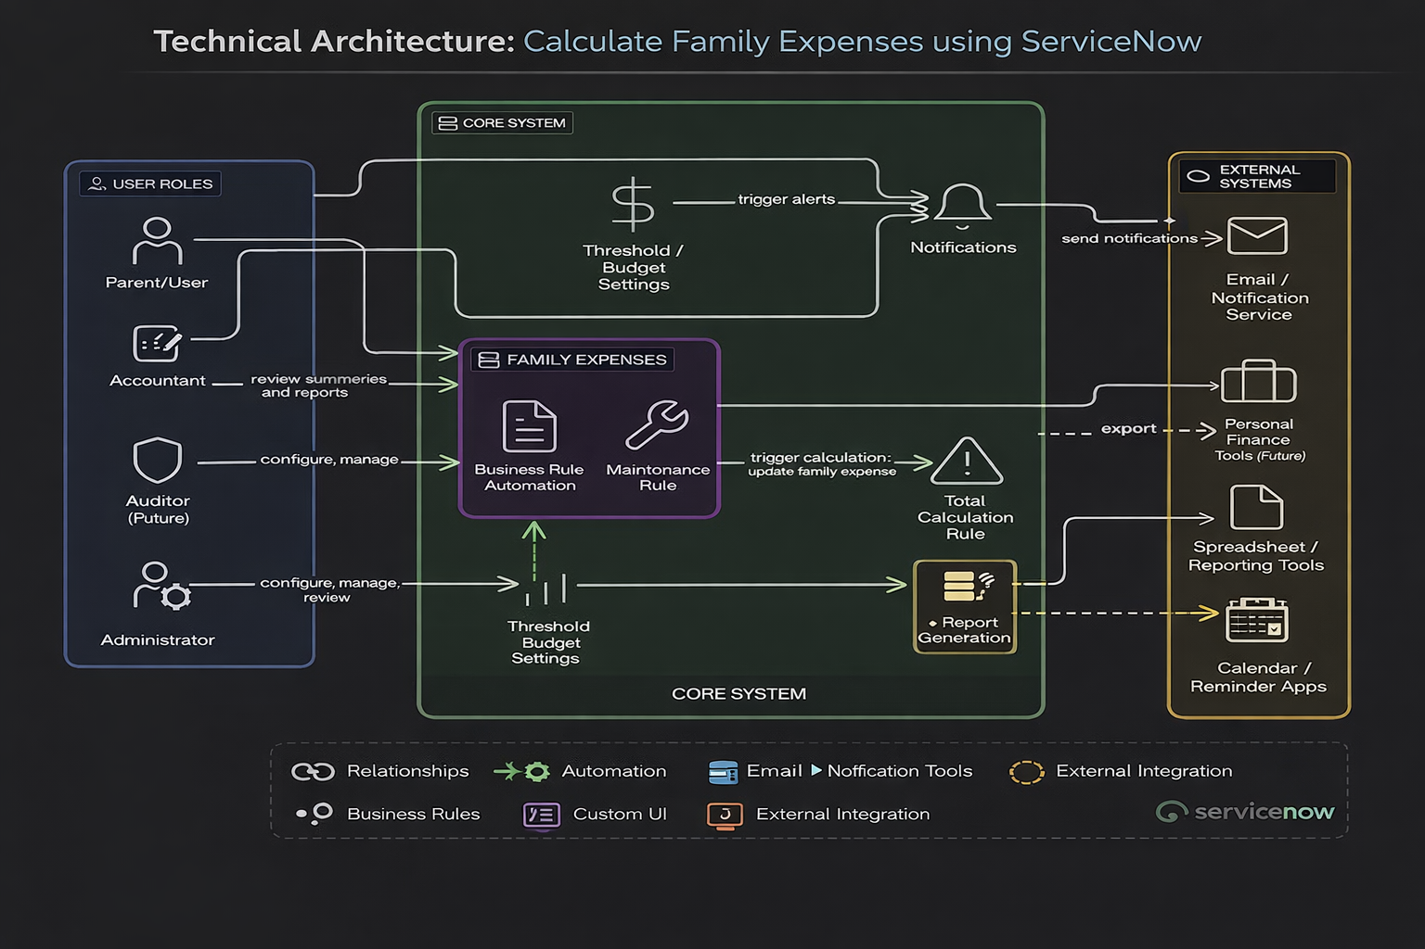

Table-1 : Components & Technologies:
S.No | Component | Description | Technology
1 | User Interface | Web-based forms and dashboards for entering daily expenses and viewing family expense summaries | ServiceNow UI Framework (Form Designer, Lists, Service Portal)
2 | Application Logic – 1 | Dynamic form behavior, field validation, read-only and mandatory field configuration | ServiceNow Client Scripts, UI Policies (JavaScript, GlideForm API)
3 | Application Logic – 2 | Automation of expense calculation and record updates when daily expenses are added | ServiceNow Business Rules (GlideRecord API, Server-side scripting)
4 | Application Logic – 3 | Auto-number generation and relationship handling between Family Expenses and Daily Expenses tables | ServiceNow Dictionary, Relationships, Auto-numbering
5 | Database | Stores family expense summaries, daily expense records, family member details, and expense history | ServiceNow Custom Tables (Family Expenses, Daily Expenses), MySQL Backend
6 | Reporting & Analytics | Generates reports and dashboards to analyze expense trends and total expenses | ServiceNow Reporting Engine, Dashboards
7 | External Integration | Enables integration with external tools like spreadsheets or financial apps for exporting reports | ServiceNow REST API
8 | Infrastructure (Cloud) | Provides secure, scalable, and cloud-based hosting environment for the expense management system | ServiceNow SaaS Cloud Infrastructure

Table-2: Application Characteristics:
S.No | Characteristic | Description | Technology
1 | Platform Framework | Uses ServiceNow low-code platform with JavaScript for automation, form logic, and business rules | ServiceNow Platform, JavaScript, Glide API
2 | Security Implementations | Ensures secure access to expense records using role-based permissions and encrypted communication | ServiceNow ACLs, HTTPS, TLS, Role-based Access Control
3 | Scalable Architecture | Cloud-based modular system that supports increasing expense records, users, and additional features like reporting and dashboards | ServiceNow Cloud Platform, Custom Tables, REST APIs
4 | Availability | Provides high availability through ServiceNow’s reliable cloud infrastructure, ensuring access to expense data with minimal downtime | ServiceNow SaaS Cloud Infrastructure
5 | Performance | Optimized record handling and automated processing using business rules, ensuring fast form submissions and data retrieval | ServiceNow GlideRecord API, Business Rules, ServiceNow Caching
6 | Data Integrity | Maintains accurate and consistent expense records using automated validation and structured database relationships | ServiceNow Database (MySQL backend), Dictionary, Relationships
7 | Maintainability | Supports easy updates and configuration tracking using update sets and modular design | ServiceNow Update Sets, Configuration Management

